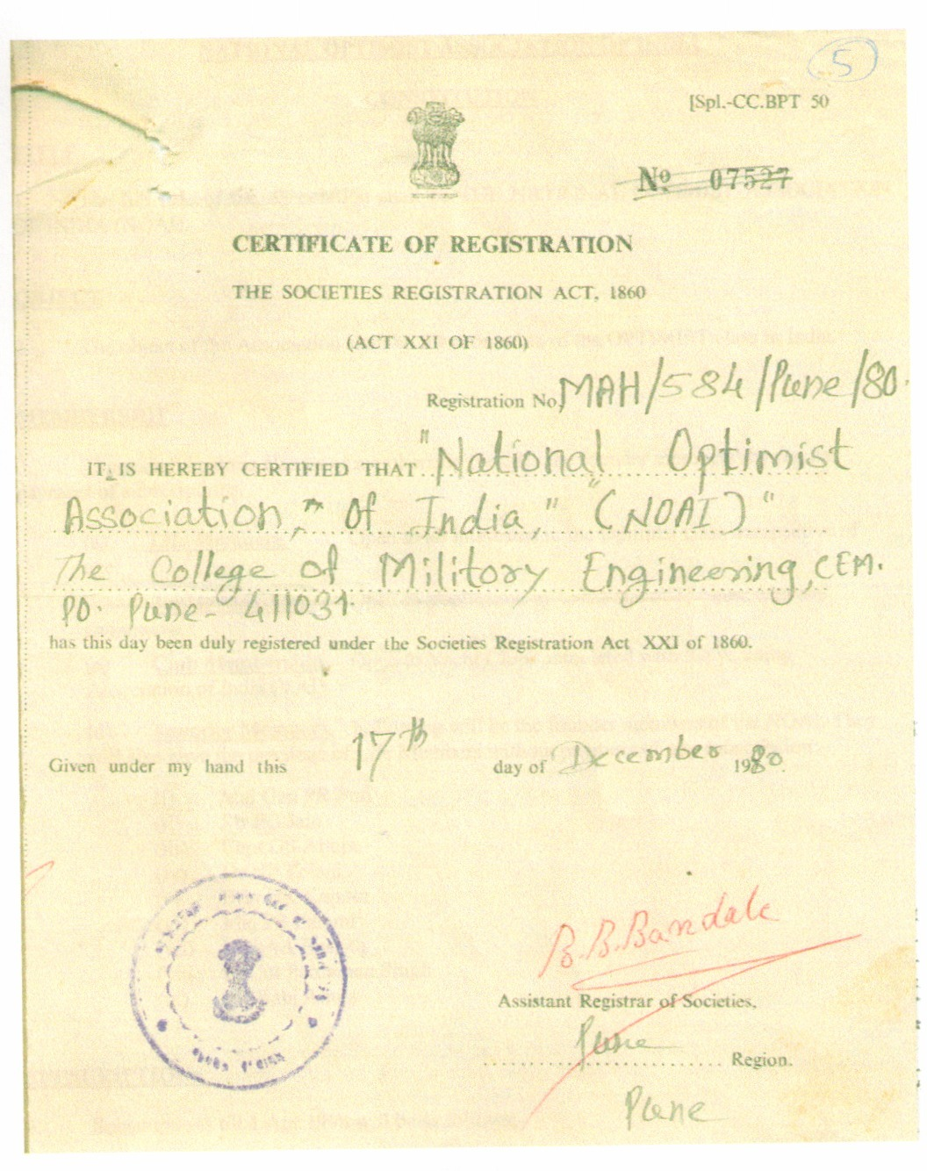
NATIONAL OPTIMIST ASSOCIATION OF INDIA

CONSTITUTION

TITLE

1. The full title of the Association shall be THE NATIONAL OPTIMIST ASSOCIATION OF INDIA (NOAI).

OBJECT

2. The object of the Association shall be the promotion of the OPTIMIST sailing in India and to represent the interests of NOAI Clubs members as follows:-

(a) To keep members informed of developments concerning the Optimist Class and any proposals concerning Class rules.

(b) To organize Championships and to co-ordinate the program for other races for the Optimist class.

(c) To encourage National and International competition in India for the Optimist class.

(d) To negotiate with the International Optimist Class Association on any matters relating to the Class Measurement Rules.

(e) To promulgate information on technical development within the Optimist class.

(f) To promote the maintenance of the one-design character of the Optimist Class.

TERMS AND DEFINITIONS

3. The following expressions shall have the associated meanings :-

(a) The “NOAI" shall mean the National Optimist Association of India.

(b) The International Association" shall mean the International Optimist Class Association formed to control the affairs of the Optimist Class throughout the world.

(c) "The Council" shall mean the Committee of the NOAI, consisting of elected Council members and other elected or appointed officials of the Association.

(d) "The NOAI Rules" shall mean these rules governing the conduct of the National Optimist Association of India.

(e) "The NOAI Register" shall mean the register of Club members and individual owners with with their addresses and details of Optimist Class boats to include hull no, sails with sail nos and other accessories to be kept as hereafter with NOAI Sectt and the measurer.

(f) "The Optimist Class" shall mean the class of sailing boat designed by Clark Mills and standardised as one-design by the IODA and made in accordance with his drawings and specifications, and known under the name Optimist.

(g) "The Class Rules" shall mean the rules relating to specification, construction and measurement controls of the Optimist Class as defined in the ISAF Equipment Rules of Sailing and governing the building of each Optimist Class boat and its rating as a recognised boat within the class for class racing purposes.

(h) "The Sail Number" shall mean the Sail Number allocated to the boat.

(j) "The National Class Secretary" shall mean the duly appointed [Honorary] Secretary of the NOAI.

(k) "Measurement/Rating Certificate" shall mean a certificate as defined in the ISAF Equipment Rules of Sailing to be issued, ratified and endorsed as hereinafter provided and recording those items recommended by the ISAF but including:-

(i) The Sail Number and initial ownership of an Optimist Class boat and any changes in ownership.

(ii) The fact that such Optimist Class boat originally complied with the Class Rules in completion of construction, together with such particulars as may be required by the Class rules.

(l) “NOAI Registration form” form required to be filled by all individuals participating in a championship giving details of their hull and duly certified by their club or club representatives.

Membership

4. There shall be the following categories of membership with power to vote at all meetings of the NOAI as indicated hereunder.

(a) Founder Members. Founder Members of the NOAI. They will also have the privilege of Life Members without payment of any subscription:-

(i) Maj Gen PR Puri.
(ii) Mr PC Jam.
(iii) Capt GS Ahuja.
(iv) Dr NP Tolani.
(v) Brig HK Kapoor.
(vi) Maj PS Pammi.
(vii) Maj AA Basisth.
(viii) Lt Col Pardaman Singh.
(ix) Mr Rabi Ahuja.

(b) Life Member. Any experienced Sailor or Official who has been actively associated with NOAI or the NOAI Sectt and has been actively working for promoting the class or association, who shall have one vote.

(c) An Associate Member. Any experienced Sailor or Official who has been actively associated with NOAI or NOAI Sectt and has been actively working for promoting the class or association, who shall be entitled to attend and speak at any general meeting of the NOAI who shall have no vote.

(d) An Honorary Member. Any person having an interest in the NOAI in India who is proposed by a Full Member and seconded by at least one member of the Council and is elected by the NOAI at any general meeting of the NOAI, who shall be entitled to attend and speak at any general meeting of the NOAI but who shall have no vote.

(e) Only individual clubs will have one vote each. State associations will not have any vote.

(f) Memberships of Associations. Associations may be formed by three or more clubs from one state and can avail association membership and will represent the interest of the clubs under them.

(g) Club Membership. Any club to be a member of NOAI should have a minimum number of five of Optimist class boats with sail nos allocated by NOAI.

(h) To retain the membership all clubs will be visited by NOAI representative once in two years to verify the club location, facilities and boats after giving a one week notice to the club. The same will be immediately carried out for new clubs seeking NOAI membership, and the expenses for the same will be borne by respective clubs.

(j) All member clubs should forward monthly list of sailors practicing in their clubs to maintain a database of all the clubs.

Entrance Fees/ Annual Subscriptions

5. The entrance fees to the NOAI, which is payable on application shall be as follows: -

(a) Life Membership (Individual) - Rs. 10,000/- valid for 10 yrs.

(b) Associate Membership - Rs. 500/-.

(c) Association Membership - Rs. 5,000/-.

(d) Club membership - Rs. 7,000/-.

6. Annual subscriptions payable by member clubs/ individual members in addition to entry fees will be as follows :-

(a) Life Membership (Individual) - Rs. 100/- per year.

(b) Associate Membership (Individual) - Rs. 100/- per year.

(c) Association Membership - Rs. 7,000/- per year.

(d) Club Membership - Rs. 5,000/- per year.

** For an individual to become a member he should be a member of one of the clubs affiliated to NOAI and the respective club should give in writing to NOAI that individual is a member of the club and provide proofs.

7. The rate of Entrance Fee and annual Subscription Fee for each category of membership of the NOAI shall be proposed by the Council to the members at the Annual General Meeting in each year. Any proposed changes shall be approved by a majority of those present and entitled to vote and shall become operative on the first day of March in the year following.

(a) All members shall pay the Entrance Fee (if any) and their first annual subscription fee upon election to the NOAI and thereafter on the first day of April in each year. Provided that a member elected after the first day of September in any year shall pay half the annual subscription fee applicable for that year and the a member elected after the first day of January of any year shall not
be required to pay any subscription fee in respect of the year of election, but shall pay, on election, the Entrance Fee and the annual Subscription Fee in respect of the year following election.

(b) Every member shall furnish the (Honorary) Secretary with an up-to-date address which shall be recorded in the register of members of the NOAI and any notice sent to such address as shall be deemed to have been duly delivered.

(c) If any club member fails to deposit the affiliation fees they will be expelled from NOAI membership after two years. In case a club wants to rejoin and was an earlier member they have to pay (subscription fees +100% of the subscription fees) x No of yrs for which the amount has not been paid.

8. Fine for late payment of yearly subscription by Clubs and individuals for the year will be as follows: -

- Payment after 30th April and before 30th Sep, 50% of subscription due.

- After 30th Sep 100% of subscription due

Election And Retirement of Members

9. (a) An application for membership shall be in the form prescribed by the Council, from time to time and shall include the name, address, and occupation of the candidate and, in the case of Honorary Members, the signatures of the Proposer and the Seconder. Details of sailing background/work experience in Optimist class certified by clubs and attached proofs are essential. Format is enclosed as Appendix ‘A’.

(b) The election/appointment of all classes of members/officials is vested in the Council and shall be a simple majority vote of those of the Council. The [Honorary] Secretary shall inform each candidate in writing of the candidate's election or non-election. He shall furnish an elected candidate with a copy of the NOAI Rules and make request for such payments as are necessary.

(c) A member desirous of retiring from membership shall give notice in writing to the [Honorary] Secretary before the last day of November and shall not then be liable to pay the subscription for the following year. Upon re-application by a past member the Council may, at its discretion, excuse payment of an Entrance Fee. Withdrawing life members will not be allowed any refund of the deposited amount.

(d) The Council may cancel, without notice being given, the membership of any member whose annual subscription and other annual fees are more than three months in arrears provided that the Council may, at its discretion, re-instate such member upon payment of arrears and late fees. No member whose annual payment is in arrears may enter any NOAI event or regatta or vote at any meeting.

Cessation of Membership

10. (a) Any member/club desirous of retiring from the NOAI shall notify his/her/its intention in writing to reach the Honorary Secretary on or before the thirty first day of March otherwise he/she/it shall be liable to pay the subscription for the following year.

(b) Every member, upon election and thereafter, is deemed to have notice of, and impliedly undertakes to comply with, the NOAI Rules. Any refusal or neglect to do so, or any conduct which, in the opinion of the Council, is either unworthy of a member or otherwise injurious to the interests of the NOAI, shall render a member liable to expulsion by the Council

(c) The council may in their absolute and unfettered discretion at any time cancel the membership of any recognised club/member.

(d) Provided That, before expelling a member, the Council shall call upon such member for a written explanation of the member's conduct and shall give the member full opportunity of making explanation to the Council, or of resigning.

(e) A Resolution to expel a member shall be carried by a simple majority vote by those members of the Council present and voting on the Resolution.

(f) Appeal against expulsion may be made to the members in general meeting.

(g) An expelled member will not be admitted again.

Entitlements and Obligations of Membership

11. (a) All members shall be entitled to receive a copy of all publications of the Association on such payment as may be determined by the Secretariat.

- All members shall be entitled to receive notice of, and to attend General Body Meeting of the Association and shall be entitled to vote.

- A member shall not knowingly remove, injure, destroy or damage any property of the NOAI and shall make restitution for the same if called upon to do so by the Council or by the [Honorary] Secretary upon the instructions of the Council.

- Membership of the NOAI and acceptance of these rules by the member will be deemed to constitute consent to the holding of relevant personal data for the purposes of National Records.

12. (a) The Officers of the NOAI shall be Full Members of the NOAI and shall consist of

(i) President, Elected.
(ii) Vice-President, Elected.
(iii) Exec Vice President, Appointed by the President.
(iv) [Honorary] Secretary, Appointed.
(v) [Honorary] Treasurer, Appointed.

(b) The Officers shall be Elected or Appointed at the Annual General Meeting of the Association or in the event of a post falling vacant an election by postal ballot as explained in clause “h” procedure for Postal Ballot shall be followed to ensure election of the next incumbent. For appointed members, they can be appointed by the president as per his discretion.

(c) The term of office of the Officers of the NOAI will not exceed two years.

(d) No office bearer shall hold the same office appointments for more than two terms.

(e) Election of office bearers may be carried out either at General Body meeting or by postal ballot (proxy voting), as decided by the Council. The Honorary Secretary shall send a notice to each member club inviting proposals for the post(s) of office bearer(s). The notice shall indicate whether the election is to take place at a General Body Meeting or by postal ballot.

(f) In case the election is to take place at a General Body Meeting, the names of the candidate(s), if any, shall be communicated by the Member Clubs to the Honorary Secretary so as to reach him before the General Body Meeting. At the General Body Meeting, member clubs may vote in person or by proxy, or by indicating their preference in writing. Voting at a General Body Meeting for any of the elective offices of the NOAI shall be by secret ballot.

(g) In case the election is to take place by postal ballot, the following procedure shall be followed :

(i) The name of candidate(s) if any shall be communicated by the member Clubs in writing to the Honorary Secretary within 30 days of dispatch of the Notice calling for election of any of the elective offices.

(ii) If there is more than one candidate for any of the elective offices, then the Honorary Secretary shall send to the Member Clubs a ballot paper by post.

(iii) The Member Clubs will return the ballot paper duly filled in within 30 days of dispatch of postal ballot.

(iv) Total time for election be restricted to two months.

(h) Any post of office bearer falling vacant during a term shall be filled for the remainder of the term by election through postal ballot however in the interim be handled by an appointee.

(j) The President shall have the power to appoint Exec vice president, Secretary, Treasurer and Assistant Secretaries and Assistant Treasurers to assist the Honorary Secretary and the Honorary Treasurer respectively. The Assistant Secretary and Assistant Treasurers shall not be considered as “Officers” of the NOAI and together with the President, Vice President, Honorary Secretary and Honorary Treasurer will constitute the Secretariat of the NOAI.

The Council

13. (a) The affairs of the NOAI shall be managed by the council.

(b) The council shall consist of the officers ex-officio i.e. President, the Vice President, Honorary Secretary, Honorary Treasurer, all of whom shall be members/appointees of affiliated clubs under NOAI and elected/appointed as per the provisions of clause 12 above. Apart from these, the General Assembly shall also elect the Measurer, the National Class Coach and the assistant coach for regions as identified in clause 14 (b).

(c) The decision of the Council will be final in all matters concerning the NOAI.

Election to the Council

14. (a) The President, The Vice President of the Association shall be elected during the Annual General Meeting for the period of two years.

(b) The regions shall be South West (Kerala); North West (Mumbai); West (Goa and Pune); Central (Hyderabad); North (Bhopal); South East (Chennai).

(c) Candidates for election to the Council (not being Officers of the National Association) shall be those members of the retiring Council eligible to offer themselves for re-election and such other Full Members whose nominations (duly proposed and seconded in writing by Full Members of the National Association) with their consent shall have been received by the [Honorary] Secretary at least twenty eight days before the date of the Annual General Meeting in each year. Such nominations, together with the names of the Proposer and Seconder shall be sent to the NOAI at least fourteen days prior to the date of the Annual General Meeting.
(d) If the number of candidates for election is greater than the number of vacancies to be filled then there shall be a ballot.

(e) If the number of candidates for election is equal to or less than the number of vacancies to be filled then all candidates shall be deemed to be elected if two thirds of those present at the Annual General Meeting, and entitled to vote, vote in favour of such election.

(f) In the event of the ballot failing to determine the members of the Council because of an equality of votes the candidate or candidates to be elected from those having an equal number of votes shall be determined by lot in which the President to have one more vote.

(g) If, for any reason, a casual vacancy shall occur, the Council may co-opt a Full Member to fill such a vacancy until the next following Annual General Meeting.

(h) The council may meet together for the despatch of business, adjourn and otherwise regulate their meetings as they think fit. The President or in his absence next in hierarchy elected/appointed by those present shall preside.

(j) Voting except in the case of a resolution relating to the expulsion of a member) shall be by show of hands. In the case of equality of votes the Chairman shall have a second and casting vote.
(k) A min of five members personally present shall form a quorum at a meeting of the Council.
(l) In the event of an Annual General Meeting not taking place in a year, the Council will continue in office till an Annual General Meeting is held for the purpose of elections.

Powers of the Council

15. (a) The Council shall manage the affairs of the NOAI according to the NOAI Rules and shall cause the funds of the NOAI to be applied solely to the objects of the NOAI or for a benevolent or charitable purpose nominated by the NOAI in general meeting.

(b) The Council may appoint such sub-committees as it may deem necessary and may delegate such of its powers as it may think fit upon such terms and conditions as shall be deemed expedient and/or required by the law. Such sub-committees shall consist of such members of the Council or of the NOAI as the Committees may think fit. Officers of the NOAI shall be ex officio members of all such sub-committees.

(c) A member of the Council, of a sub-committee or any officer of the National Association, in transacting business for the National Association, shall disclose to third parties that he is so acting. Provided he is so authorised by council.

(d) The Council, or any person or sub-committees delegated by the Council to act as agent for the NOAI or its members, shall enter into contract only as far as expressly authorised, or authorised by implication, by the members. No one shall, without the express authority of the membership in general meeting, pledge the credit of the membership.

(e) In pursuance of the authority vested in the Council by members of the National Association, members of the Council are entitled to be indemnified by the members of the NOAI against any liabilities properly incurred by them or any one of them on behalf of the NOAI wherever the contract is of a duly authorised nature or could be assumed to be of a duly authorised nature and entered into on behalf of the National Association.

(f) The limit of any individual member's indemnity in this respect shall be a sum equal to one year's subscription at the then current rate of that category of membership unless the Council has been authorised to exceed such limit laid time to time by a general meeting of the National Association.

Duties of Officers of the Association

16. (a) President. The President shall preside over all the meetings of the NOAI and perform such other duties as may be delegated to him by the Council. He/She shall appoint the Exec Vice President, Honorary Secretary and Treasurer.

(b) The Vice President . The Vice President shall assist the President, preside over all meetings in absence of the President and perform such other duties as may be delegated to him by the Council.

(c) Exec Vice President. The Exec Vice President shall on behalf of President will monitor all actions of NOAI and perform such other duties. Manage functioning of the NOAI Sectt. He will conduct the AGM and ensure it is followed as per constitution.

(d) Honorary Secretary. The [Honorary] Secretary shall:-

(i) Keep the NOAI Register and Boat Register with details of boats and owner.
(ii) Keep a register of NOAI members' names and addresses.
(iii) Conduct the correspondence of the National Association.
(iv) Keep custody of all NOAI documents.
(v) Keep full minutes of all meetings of the National Association, the Council as defined in Clause 13 which shall be confirmed and signed by the appropriate Chairman upon the agreement of the NOAI or the Council at the next following meeting of the NOAI or the Council, as appropriate.
(vi) Administer such insurance policy or policies as may be needed fully to protect the interests of the National Association, its Officers and its members.
(vii) Communicate the decisions of the Council to the National Association, to the secretariat of the International Association and, when directed by the Council, non-members of the National Association.
(viii) Maintain any such certificates or registrations, and complete any such non-financial returns, as may be required by law.

(e) Honorary Treasurer. The [Honorary] Treasurer shall:

(i) Cause such books of account to be kept as are necessary to give a true and fair view of the state of finances of the National Association.
(ii) Cause all returns as may be required by law in relation to such accounts to be rendered at the due time.
(iii) Make such payments on behalf of the National Association as the Council shall direct.
(iv) Prepare an annual financial statement each year and cause such financial statement to be audited at least once annually and shall thereafter cause the same to be sent to all members of the NOAI at least fourteen days before the date of the Annual General Meeting
(v) Present the annual financial statement to the National Association at its Annual General Meeting.

(f) Measurer. The Measurer will ensure that class rules of the Optimist are observed. He will also issue measurement certificates for all newly constructed boats as per Performa laid down by the International Optimist Class Association.

(g) National Optimist Coach. The National Optimist Coach shall be elected to the council and will advice the council on the efforts and plans required to promote the class in the country. He shall report to the council and will be the NOAI proposed member to the Yachting Association of India’s Selection Committee.

Meetings of the National Optimist Association of India

17. An Annual General Meeting of the NOAI shall be held each year in conjunction with any National or International Optimist event in the country at the venue of the championship. The [Honorary] Secretary shall at least fourteen days before the date of such meeting post or deliver to each member notice hereof and of the business to be brought forward thereat.

(a) No business, except the passing of the Accounts and the election of the Officers, Council and Honorary Auditors, and any business that the Council may order to be inserted in the notice convening the meeting shall be discussed at such meeting unless notice thereof be given in writing by a member entitled to vote to the [Honorary] Secretary at least forty two days before the date of the Annual General Meeting.

(b) The Council may at any time, upon giving twenty one days notice in writing, call a special General Meeting of the NOAI for any special business, the nature of which shall be stated in the summons convening the meeting, and the discussion at such meeting shall be confined to the business stated in the notice sent to members.

(c) The Council shall call a Special General Meeting upon a written request addressed to the [Honorary] Secretary by at least [Five] members. The Council shall give twenty one days notice in writing of any such Special General Meeting. The discussion at such meeting shall be confined to the business stated in the notice sent to members.

(d) At every meeting of the NOAI the Chairman (or, in their absence, a chairman elected by those present) shall preside.

(e) A minimum of five members entitled to vote and personally present shall form a quorum at any meeting of the National Association.

(f) Only Full Members shall vote at any meeting of the National Association. Other members may attend and speak but are not entitled to vote.

(g) Voting, except upon the election of members of the Council, shall be by show of hands.
(h) In the case of an equality of votes the Chairman shall have a second or casting vote, on any matter other than the election of members of the Council.

(j) On any resolution properly put to a meeting of the NOAI relating to the creation, repeal or amendment of any provisions shall not be created, repealed or amended except by a majority vote of at least two-thirds of those present and entitled to vote.

(k) On any resolution properly put to a meeting of the NOAI relating to the creation, repeal or amendment of any Class Rule, such resolution shall not be adopted except by a majority vote of at least two-thirds of those present and entitled to vote.

Voting Power at General Meetings

18. (a) Only Founder members, Life Members and individual clubs shall be entitled to vote.

(b) A life member or Club member shall be entitled to depute one or more representatives to attend on its behalf the General or other meetings of the NOAI but shall appoint only one of them by name to exercise all its rights of voting. Production of the written authorisation by the Member Club or of the voting papers or paper issued to a member club which is entitled to vote at a General Meeting of the NOAI shall be deemed to be due authorisation to the bearer to vote on such member club’s behalf at that meeting.

(c) A full member both individual and club/association may vote by proxy; a member club may also send its views in writing (so as to reach the Honorary Secretary on or before the General Meeting) on any business to be transacted at a General Meeting, which shall be considered for the purpose of counting the votes.

Procedure on a Ballot

19. (a) One ballot paper shall be sent to a Life member and individual Clubs in respect of each vote to which the Member is entitled on a ballot.

- Every ballot paper when completed by the life member and individual Club to whom it is sent, must contain one vote in favour of vacancies to be filled; otherwise it shall be treated as a spoiled paper.

(c) Properly completed ballot papers received by the Honorary Secretary of the NOAI not later than the time fixed for the General Meeting/or at the NOAI Sectt at which the result is to be declared shall alone be taken into account.

(d) Where a vote is taken by postal ballot, the properly completed ballot papers must reach the Honorary Secretary within the time period stipulated.

Notices

20. A notice or any other document may be served by the NOAI upon any member Club or life member either directly or by sending it through the postal addressed/ email to such member or Club at its last known address, but the accidental omission to give such notice document by any such member Club, shall not invalidate any resolution passed of election connected herewith.

Arbitration

21. (a) Disputes between members or member Clubs will be referred to NOAI for appointing an arbitrator for settlement of disputes. Verdict of the appointed arbitrator will be final and binding on the parties involved in the dispute.

(b) Disputes between members or member Clubs and NOAI will be referred to the YAI for appointing an arbitrator or team of arbitrators. In case of team, one arbitrator each will be appointed by the disputing parties and the two nominated arbitrators will appoint an Umpire. The verdict/decision of the team comprising of the umpire and the two arbitrators will be final and binding on the disputing parties.

(c) Provisions of Arbitration Act 1940 or the revisions thereof will apply to disputes referred for arbitration.

Auditors

22. The Council shall have power to appoint an auditor annually and to fix his remuneration.

Year

23. The financial year of the Association shall be 1st Apr to 31 March.

Dissolution of Association

24. In case of dissolution of Association, the procedure laid down in Sec 13 & 14 of SR Act 1860 shall be observed.

Change in Name, Objects and Amalgamation Etc

25. In case of changes in the object of the Association or in the name of the Assn or amalgamation, the procedure laid down in Sec 12 and 12A of SR Act 1860 shall be followed.

